**Data Analysis with Python**

Last Updated : 20 Jan, 2025

In this article, we will discuss how to do data analysis with Python. We will discuss all sorts of data analysis i.e. analyzing numerical data with NumPy, Tabular data with Pandas, data visualization Matplotlib, and Exploratory data analysis.

**Data Analysis With Python**

**Data Analysis** is the technique of collecting, transforming, and organizing data to make future predictions and informed data-driven decisions. It also helps to find possible solutions for a business problem. There are six steps for Data Analysis. They are:

* Ask or Specify Data Requirements
* Prepare or Collect Data
* Clean and Process
* Analyze
* Share
* Act or Report

*Data Analysis with Python*

**Note:** To know more about these steps refer to our [Six Steps of Data Analysis Process](https://www.geeksforgeeks.org/six-steps-of-data-analysis-process/) tutorial.

**Analyzing Numerical Data with NumPy**

[NumPy](https://www.geeksforgeeks.org/python-numpy/) is an array processing package in Python and provides a high-performance multidimensional array object and tools for working with these arrays. It is the fundamental package for scientific computing with Python.

**Arrays in NumPy**

[NumPy Array](https://www.geeksforgeeks.org/basics-of-numpy-arrays/) is a table of elements (usually numbers), all of the same types, indexed by a tuple of positive integers. In Numpy, the number of dimensions of the array is called the rank of the array. A tuple of integers giving the size of the array along each dimension is known as the shape of the array.

**Creating NumPy Array**

NumPy arrays can be created in multiple ways, with various ranks. It can also be created with the use of different data types like lists, tuples, etc. The type of the resultant array is deduced from the type of elements in the sequences. NumPy offers several functions to create arrays with initial placeholder content. These minimize the necessity of growing arrays, an expensive operation.

**Create Array using [numpy.empty(shape, dtype=float, order=’C’)](https://www.geeksforgeeks.org/numpy-empty-python/)**



1

import numpy as np

2

​

3

a = np.empty([2, 2], dtype = int)

4

print("\nMatrix a : \n", a)

5

​

6

b = np.empty(2, dtype = int)

7

print("Matrix b : \n", b)

**Output**

Matrix a :

[[ 94655291709206 0]

[3543826506195694713 34181816989462323]]

Matrix b :

[-4611686018427387904 206158462975]

**Create Array using [numpy.zeros(shape, dtype = None, order = ‘C’)](https://www.geeksforgeeks.org/numpy-zeros-python/)**



1

import numpy as np

2

​

3

a = np.zeros([2, 2], dtype = int)

4

print("\nMatrix a : \n", a)

5

​

6

b = np.zeros(2, dtype = int)

7

print("Matrix b : \n", b)

8

9

c = np.zeros([3, 3])

10

print("\nMatrix c : \n", c)

**Output**

Matrix a :

[[0 0]

[0 0]]

Matrix b :

[0 0]

Matrix c :

[[0. 0. 0.]

[0. 0. 0.]

[0. 0. 0.]]

**Operations on Numpy Arrays**

**Arithmetic Operations**

* **Addition:**



1

import numpy as np

2

​

3

a = np.array([5, 72, 13, 100])

4

b = np.array([2, 5, 10, 30])

5

​

6

add_ans = a+b

7

print(add_ans)

8

​

9

add_ans = np.add(a, b)

10

print(add_ans)

11

​

12

c = np.array([1, 2, 3, 4])

13

add_ans = a+b+c

14

print(add_ans)

15

​

16

add_ans = np.add(a, b, c)

17

print(add_ans)

**Output**

[ 7 77 23 130]

[ 7 77 23 130]

[ 8 79 26 134]

[ 7 77 23 130]

* **Subtraction:**



1

import numpy as np

2

​

3

a = np.array([5, 72, 13, 100])

4

b = np.array([2, 5, 10, 30])

5

​

6

sub_ans = a-b

7

print(sub_ans)

8

​

9

sub_ans = np.subtract(a, b)

10

print(sub_ans)

**Output**

[ 3 67 3 70]

[ 3 67 3 70]

* **Multiplication:**



1

import numpy as np

2

​

3

a = np.array([5, 72, 13, 100])

4

b = np.array([2, 5, 10, 30])

5

​

6

mul_ans = a*b

7

print(mul_ans)

8

​

9

mul_ans = np.multiply(a, b)

10

print(mul_ans)

**Output**

[ 10 360 130 3000]

[ 10 360 130 3000]

* **Division:**



1

import numpy as np

2

​

3

a = np.array([5, 72, 13, 100])

4

b = np.array([2, 5, 10, 30])

5

​

6

div_ans = a/b

7

print(div_ans)

8

​

9

div_ans = np.divide(a, b)

10

print(div_ans)

**Output**

[ 2.5 14.4 1.3 3.33333333]

[ 2.5 14.4 1.3 3.33333333]

For more information, refer to our [NumPy – Arithmetic Operations Tutorial](https://www.geeksforgeeks.org/numpy-arithmetic-operations/)

**NumPy Array Indexing**

[Indexing](https://www.geeksforgeeks.org/numpy-indexing/) can be done in NumPy by using an array as an index. In the case of the slice, a view or shallow copy of the array is returned but in the index array, a copy of the original array is returned. Numpy arrays can be indexed with other arrays or any other sequence with the exception of tuples. The last element is indexed by -1 second last by -2 and so on.

**Python NumPy Array Indexing**



1

import numpy as np

2

​

3

a = np.arange(10, 1, -2)

4

print("\n A sequential array with a negative step: \n",a)

5

​

6

newarr = a[np.array([3, 1, 2 ])]

7

print("\n Elements at these indices are:\n",newarr)

**Output**

A sequential array with a negative step:

[10 8 6 4 2]

Elements at these indices are:

[4 8 6]

**NumPy Array Slicing**

Consider the syntax x[obj] where x is the array and obj is the index. The slice object is the index in the case of [basic slicing](https://www.geeksforgeeks.org/indexing-in-numpy/). Basic slicing occurs when obj is :

* a slice object that is of the form start: stop: step
* an integer
* or a tuple of slice objects and integers

All arrays generated by basic slicing are always the view in the original array.



1

import numpy as np

2

​

3

a = np.arange(20)

4

print("\n Array is:\n ",a)

5

​

6

print("\n a[-8:17:1] = ",a[-8:17:1])

7

​

8

print("\n a[10:] = ",a[10:])

**Output**

Array is:

[ 0 1 2 3 4 5 6 7 8 9 10 11 12 13 14 15 16 17 18 19]

a[-8:17:1] = [12 13 14 15 16]

a[10:] = [10 11 12 13 14 15 16 17 18 19]



1

import numpy as np

2

​

3

a = np.arange(20)

4

print("\n Array is:\n ",a)

5

​

6

print("\n a[-8:17:1] = ",a[-8:17:1])

7

​

8

print("\n a[10:] = ",a[10:])

**Output**

Array is:

[ 0 1 2 3 4 5 6 7 8 9 10 11 12 13 14 15 16 17 18 19]

a[-8:17:1] = [12 13 14 15 16]

a[10:] = [10 11 12 13 14 15 16 17 18 19]

Ellipsis can also be used along with basic slicing. Ellipsis (…) is the number of : objects needed to make a selection tuple of the same length as the dimensions of the array.



1

import numpy as np

2

​

3

b = np.array([[[1, 2, 3],[4, 5, 6]],

4

[[7, 8, 9],[10, 11, 12]]])

5

​

6

print(b[...,1])

**Output**

[[ 2 5]

[ 8 11]]

**NumPy Array Broadcasting**

The term [broadcasting](https://www.geeksforgeeks.org/python-broadcasting-with-numpy-arrays/) refers to how numpy treats arrays with different Dimensions during arithmetic operations which lead to certain constraints, the smaller array is broadcast across the larger array so that they have compatible shapes.

Let’s assume that we have a large data set, each datum is a list of parameters. In Numpy we have a 2-D array, where each row is a datum and the number of rows is the size of the data set. Suppose we want to apply some sort of scaling to all these data every parameter gets its own scaling factor or say Every parameter is multiplied by some factor.

Just to have a clear understanding, let’s count calories in foods using a macro-nutrient breakdown. Roughly put, the caloric parts of food are made of fats (9 calories per gram), protein (4 CPG), and carbs (4 CPG). So if we list some foods (our data), and for each food list its macro-nutrient breakdown (parameters), we can then multiply each nutrient by its caloric value (apply scaling) to compute the caloric breakdown of every food item.

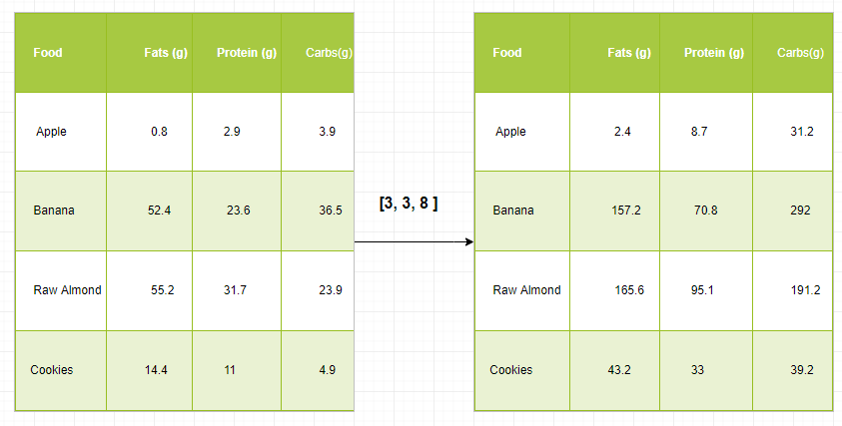

With this transformation, we can now compute all kinds of useful information. For example, what is the total number of calories present in some food or, given a breakdown of my dinner know how many calories did I get from protein and so on.

**Let’s see a naive way of producing this computation with Numpy:**



1

import numpy as np

2

​

3

macros = np.array([

4

[0.8, 2.9, 3.9],

5

[52.4, 23.6, 36.5],

6

[55.2, 31.7, 23.9],

7

[14.4, 11, 4.9]

8

])

9

​

10

cal_per_macro = np.array([3, 3, 8])

11

​

12

result = macros * cal_per_macro

13

​

14

print(result)

**Output**

[[ 2.4 8.7 31.2]

[157.2 70.8 292. ]

[165.6 95.1 191.2]

[ 43.2 33. 39.2]]

**Broadcasting Rules:** Broadcasting two arrays together follow these rules:

* If the arrays don’t have the same rank then prepend the shape of the lower rank array with 1s until both shapes have the same length.
* The two arrays are compatible in a dimension if they have the same size in the dimension or if one of the arrays has size 1 in that dimension.
* The arrays can be broadcast together if they are compatible with all dimensions.
* After broadcasting, each array behaves as if it had a shape equal to the element-wise maximum of shapes of the two input arrays.
* In any dimension where one array had a size of 1 and the other array had a size greater than 1, the first array behaves as if it were copied along that dimension.



1

import numpy as np

2

​

3

v = np.array([12, 24, 36])

4

w = np.array([45, 55])

5

​

6

print(np.reshape(v, (3, 1)) * w)

7

​

8

X = np.array([[12, 22, 33], [45, 55, 66]])

9

​

10

print(X + v)

11

​

12

print((X.T + w).T)

13

​

14

print(X * 2)

**Output**

[[ 540 660]

[1080 1320]

[1620 1980]]

[[ 24 46 69]

[ 57 79 102]]

[[ 57 67 78]

[100 110 121]]

[[ 24 44 66]

[ 90 110 132]]

**Note:**For more information, refer to our [Python NumPy Tutorial](https://www.geeksforgeeks.org/numpy-tutorial/).

**Analyzing Data Using Pandas**

Python Pandas Is used for relational or labeled data and provides various data structures for manipulating such data and time series. This library is built on top of the NumPy library. This module is generally imported as:

import pandas as pd

Here, pd is referred to as an alias to the Pandas. However, it is not necessary to import the library using the alias, it just helps in writing less amount code every time a method or property is called. Pandas generally provide two data structures for manipulating data, They are:

* Series
* Dataframe

**Series:**

[Pandas Series](https://www.geeksforgeeks.org/python-pandas-series/) is a one-dimensional labeled array capable of holding data of any type (integer, string, float, python objects, etc.). The axis labels are collectively called indexes. Pandas Series is nothing but a column in an excel sheet. Labels need not be unique but must be a hashable type. The object supports both integer and label-based indexing and provides a host of methods for performing operations involving the index.

*Pandas Series*

It can be created using the Series() function by loading the dataset from the existing storage like SQL, Database, CSV Files, Excel Files, etc., or from data structures like lists, dictionaries, etc.

**Python Pandas Creating Series**



1

import pandas as pd

2

import numpy as np

3

​

4

ser = pd.Series(dtype="object")

5

​

6

print(ser)

7

​

8

data = np.array(['g', 'e', 'e', 'k', 's'])

9

​

10

ser = pd.Series(data)

11

print(ser)

**Output**

Series([], dtype: object)

0 g

1 e

2 e

3 k

4 s

dtype: object

**Dataframe:**

[Pandas DataFrame](https://www.geeksforgeeks.org/python-pandas-dataframe/) is a two-dimensional size-mutable, potentially heterogeneous tabular data structure with labeled axes (rows and columns). A Data frame is a two-dimensional data structure, i.e., data is aligned in a tabular fashion in rows and columns. Pandas DataFrame consists of three principal components, the data, rows, and columns.

*Pandas Dataframe*

It can be created using the Dataframe() method and just like a series, it can also be from different file types and data structures.

**Python Pandas Creating Dataframe**



1

import pandas as pd

2

​

3

df = pd.DataFrame()

4

print(df)

5

​

6

lst = ['Geeks', 'For', 'Geeks', 'is', 'portal', 'for', 'Geeks']

7

​

8

df = pd.DataFrame(lst, columns=['Words'])

9

​

10

print(df)

**Output**

Empty DataFrame

Columns: []

Index: []

Words

0 Geeks

1 For

2 Geeks

3 is

4 portal

5 for

6 Geeks

**Creating Dataframe from CSV**

We can [create a dataframe from the CSV](https://www.geeksforgeeks.org/creating-a-dataframe-using-csv-files/) files using the [read_csv()](https://www.geeksforgeeks.org/python-read-csv-using-pandas-read_csv/) function.

**Python Pandas read CSV**

**import** **pandas** **as** **pd**

df = pd.read_csv("Iris.csv")

df.head()

**Output:**

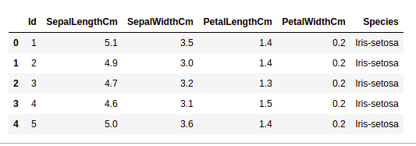

*head of  a dataframe*

**Filtering DataFrame**

Pandas [dataframe.filter()](https://www.geeksforgeeks.org/python-pandas-dataframe-filter/) function is used to Subset rows or columns of dataframe according to labels in the specified index. Note that this routine does not filter a dataframe on its contents. The filter is applied to the labels of the index.

**Python Pandas Filter Dataframe**

**import** **pandas** **as** **pd**

df = pd.read_csv("Iris.csv")

df.filter(["Species", "SepalLengthCm", "SepalLengthCm"]).head()

**Output:**

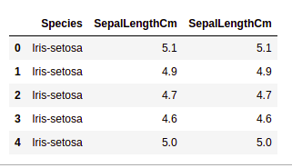

*Applying filter on dataset*

**Sorting DataFrame**

In order to sort the data frame in pandas, the function [sort_values()](https://www.geeksforgeeks.org/python-pandas-dataframe-sort_values-set-1/) is used. Pandas sort_values() can sort the data frame in Ascending or Descending order.

**Python Pandas Sorting Dataframe in Ascending Order**

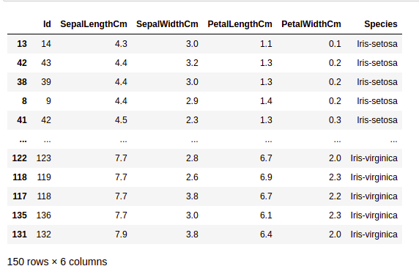

*Sorted dataset based on a column value*

**Pandas GroupBy**

[Groupby](https://www.geeksforgeeks.org/pandas-groupby/) is a pretty simple concept. We can create a grouping of categories and apply a function to the categories. In real data science projects, you’ll be dealing with large amounts of data and trying things over and over, so for efficiency, we use the Groupby concept.  Groupby mainly refers to a process involving one or more of the following steps they are:

* **Splitting:** It is a process in which we split data into group by applying some conditions on datasets.
* **Applying:**It is a process in which we apply a function to each group independently.
* **Combining:**It is a process in which we combine different datasets after applying groupby and results into a data structure.

The following image will help in understanding the process involve in the Groupby concept.

1. Group the unique values from the Team column

*Pandas Groupby Method*

2. Now there’s a bucket for each group

3. Toss the other data into the buckets

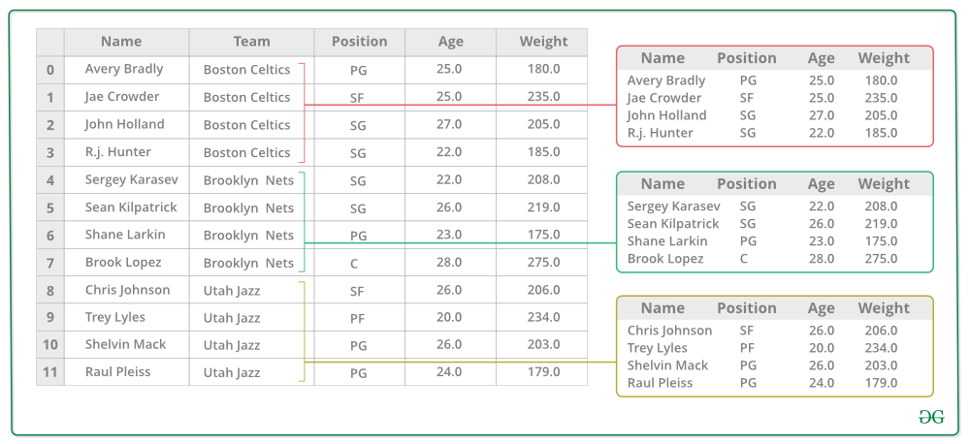

4. Apply a function on the weight column of each bucket.

*Applying Function on the weight column of each column*

**Python Pandas GroupBy:**

**import** **pandas** **as** **pd**

data1 = {'Name': ['Jai', 'Anuj', 'Jai', 'Princi',

'Gaurav', 'Anuj', 'Princi', 'Abhi'],

'Age': [27, 24, 22, 32,

33, 36, 27, 32],

'Address': ['Nagpur', 'Kanpur', 'Allahabad', 'Kannuaj',

'Jaunpur', 'Kanpur', 'Allahabad', 'Aligarh'],

'Qualification': ['Msc', 'MA', 'MCA', 'Phd',

'B.Tech', 'B.com', 'Msc', 'MA']}

df = pd.DataFrame(data1)

print("Original Dataframe")

print(df)

gk = df.groupby('Name')

print("After Creating Groups")

gk.first()

**Output:**

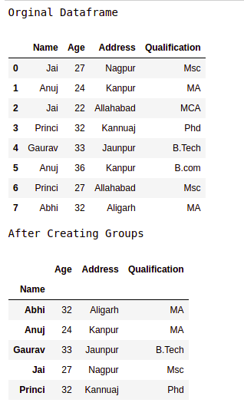

*pandas groupby*

**Applying function to group:**

After splitting a data into a group, we apply a function to each group in order to do that we perform some operations they are:

* **Aggregation:**It is a process in which we compute a summary statistic (or statistics) about each group. For Example, Compute group sums or means
* **Transformation:**It is a process in which we perform some group-specific computations and return a like-indexed. For Example, Filling NAs within groups with a value derived from each group
* **Filtration:** It is a process in which we discard some groups, according to a group-wise computation that evaluates True or False. For Example, Filtering out data based on the group sum or mean

**Pandas Aggregation**

[Aggregation](https://www.geeksforgeeks.org/grouping-and-aggregating-with-pandas/) is a process in which we compute a summary statistic about each group. The aggregated function returns a single aggregated value for each group. After splitting data into groups using groupby function, several aggregation operations can be performed on the grouped data.

**Python Pandas Aggregation**

**import** **pandas** **as** **pd**

data1 = {'Name': ['Jai', 'Anuj', 'Jai', 'Princi',

'Gaurav', 'Anuj', 'Princi', 'Abhi'],

'Age': [27, 24, 22, 32,

33, 36, 27, 32],

'Address': ['Nagpur', 'Kanpur', 'Allahabad', 'Kannuaj',

'Jaunpur', 'Kanpur', 'Allahabad', 'Aligarh'],

'Qualification': ['Msc', 'MA', 'MCA', 'Phd',

'B.Tech', 'B.com', 'Msc', 'MA']}

df = pd.DataFrame(data1)

grp1 = df.groupby('Name')

result = grp1['Age'].aggregate('sum')

print(result)

**Output:**

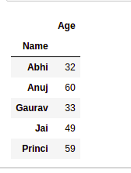

*Use of sum aggregate function on dataset*

**Concatenating DataFrame**

In order to concat the dataframe, we use [concat()](https://www.geeksforgeeks.org/pandas-concat-function-in-python/) function which helps in concatenating the dataframe. This function does all the heavy lifting of performing concatenation operations along with an axis of Pandas objects while performing optional set logic (union or intersection) of the indexes (if any) on the other axes.

**Python Pandas Concatenate Dataframe**

**import** **pandas** **as** **pd**

data1 = {'key': ['K0', 'K1', 'K2', 'K3'],

'Name': ['Jai', 'Princi', 'Gaurav', 'Anuj'],

'Age': [27, 24, 22, 32]}

data2 = {'key': ['K0', 'K1', 'K2', 'K3'],

'Address': ['Nagpur', 'Kanpur', 'Allahabad', 'Kannuaj'],

'Qualification': ['Btech', 'B.A', 'Bcom', 'B.hons']}

df = pd.DataFrame(data1)

df1 = pd.DataFrame(data2)

res = pd.concat([df, df1], axis=1)

print(res)

**Output:**

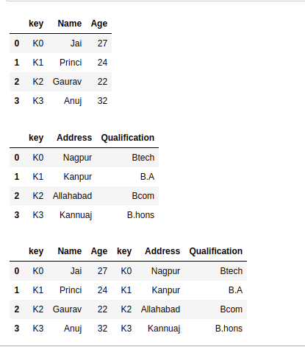

**Merging DataFrame**

When we need to combine very large DataFrames, joins serve as a powerful way to perform these operations swiftly. Joins can only be done on two DataFrames at a time, denoted as left and right tables. The key is the common column that the two DataFrames will be joined on. It’s a good practice to use keys that have unique values throughout the column to avoid unintended duplication of row values. Pandas provide a single function, [merge()](https://www.geeksforgeeks.org/joining-two-pandas-dataframes-using-merge/), as the entry point for all standard database join operations between DataFrame objects.

There are four basic ways to handle the join (inner, left, right, and outer), depending on which rows must retain their data.

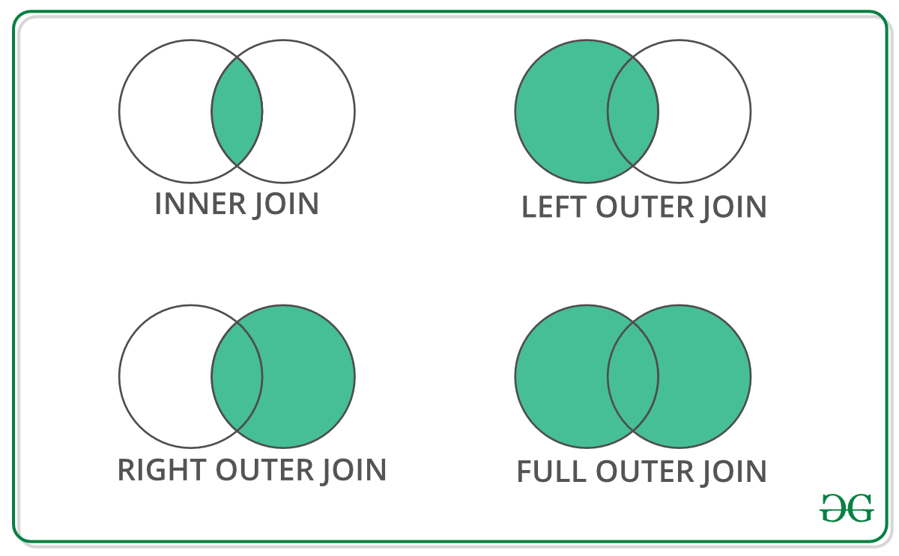

**Python Pandas Merge Dataframe**

**import** **pandas** **as** **pd**

data1 = {'key': ['K0', 'K1', 'K2', 'K3'],

'Name':['Jai', 'Princi', 'Gaurav', 'Anuj'],

'Age':[27, 24, 22, 32],}

data2 = {'key': ['K0', 'K1', 'K2', 'K3'],

'Address':['Nagpur', 'Kanpur', 'Allahabad', 'Kannuaj'],

'Qualification':['Btech', 'B.A', 'Bcom', 'B.hons']}

df = pd.DataFrame(data1)

df1 = pd.DataFrame(data2)

display(df,df1)

res = pd.merge(df, df1, on='key')

print(res)

**Output:**

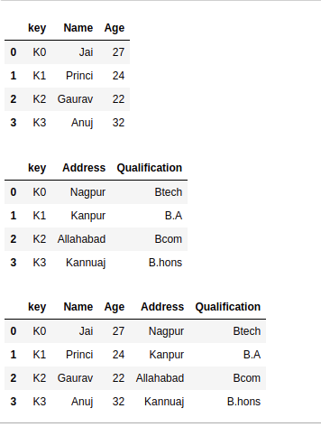

*Concatinating Two datasets*

**Joining DataFrame**

In order to join the dataframe, we use [.join()](https://www.geeksforgeeks.org/python-string-join-method/) function this function is used for combining the columns of two potentially differently indexed DataFrames into a single result DataFrame.

**Python Pandas Join Dataframe**

**import** **pandas** **as** **pd**

data1 = {'Name':['Jai', 'Princi', 'Gaurav', 'Anuj'],

'Age':[27, 24, 22, 32]}

data2 = {'Address':['Allahabad', 'Kannuaj', 'Allahabad', 'Kannuaj'],

'Qualification':['MCA', 'Phd', 'Bcom', 'B.hons']}

df = pd.DataFrame(data1,index=['K0', 'K1', 'K2', 'K3'])

df1 = pd.DataFrame(data2, index=['K0', 'K2', 'K3', 'K4'])

res = df.join(df1)

print(res)

**Output:**

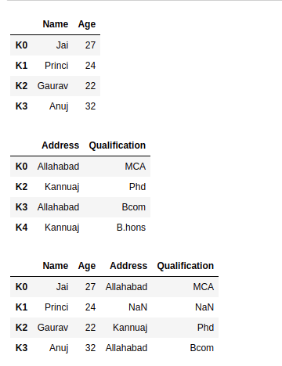

*Joining two datasets*

For more information, refer to our [Pandas Merging, Joining, and Concatenating](https://www.geeksforgeeks.org/python-pandas-merging-joining-and-concatenating/) tutorial

For a complete guide on Pandas refer to our [Pandas Tutorial](https://www.geeksforgeeks.org/pandas-tutorial/).

**Visualization with Matplotlib**

Matplotlib is easy to use and an amazing visualizing library in Python. It is built on NumPy arrays and designed to work with the broader SciPy stack and consists of several plots like line, bar, scatter, histogram, etc.

**Pyplot**

[**Pyplot**](https://www.geeksforgeeks.org/pyplot-in-matplotlib/) is a Matplotlib module that provides a MATLAB-like interface. Pyplot provides functions that interact with the figure i.e. creates a figure, decorates the plot with labels, and creates a plotting area in a figure.

**import** **matplotlib.pyplot** **as** **plt**

plt.plot([1, 2, 3, 4], [1, 4, 9, 16])

plt.axis([0, 6, 0, 20])

plt.show()

**Output:**

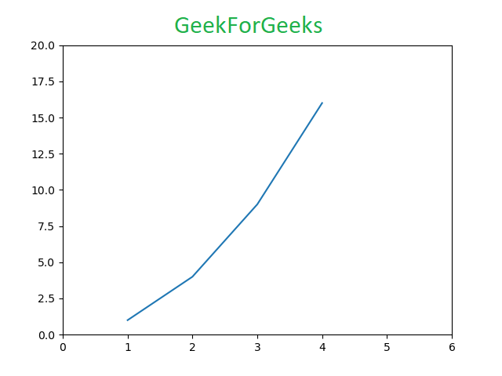

**Bar chart**

A [bar plot](https://www.geeksforgeeks.org/bar-plot-in-matplotlib/) or bar chart is a graph that represents the category of data with rectangular bars with lengths and heights that is proportional to the values which they represent. The bar plots can be plotted horizontally or vertically. A bar chart describes the comparisons between the discrete categories. It can be created using the bar() method.

**Python Matplotlib Bar Chart** Here we will use the iris dataset only

**import** **matplotlib.pyplot** **as** **plt**

**import** **pandas** **as** **pd**

df = pd.read_csv("Iris.csv")

plt.bar(df['Species'], df['SepalLengthCm'])

plt.title("Iris Dataset")

plt.legend(["bar"])

plt.show()

**Output:**

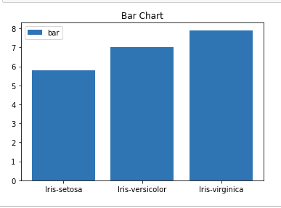

*Bar chart using matplotlib library*

**Histograms**

A [histogram](https://www.geeksforgeeks.org/plotting-histogram-in-python-using-matplotlib/) is basically used to represent data in the form of some groups. It is a type of bar plot where the X-axis represents the bin ranges while the Y-axis gives information about frequency. To create a histogram the first step is to create a bin of the ranges, then distribute the whole range of the values into a series of intervals, and count the values which fall into each of the intervals. Bins are clearly identified as consecutive, non-overlapping intervals of variables. The [hist()](https://www.geeksforgeeks.org/matplotlib-pyplot-hist-in-python/) function is used to compute and create a histogram of x.

**Python Matplotlib Histogram**

**import** **matplotlib.pyplot** **as** **plt**

**import** **pandas** **as** **pd**

df = pd.read_csv("Iris.csv")

plt.hist(df["SepalLengthCm"])

plt.title("Histogram")

plt.legend(["SepalLengthCm"])

plt.show()

**Output:**

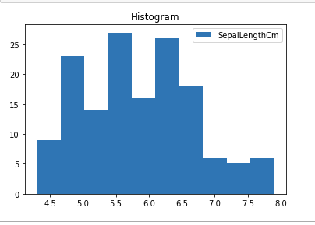

*Histplot using matplotlib library*

**Scatter Plot**

Scatter plots are used to observe relationship between variables and uses dots to represent the relationship between them. The [scatter()](https://www.geeksforgeeks.org/matplotlib-pyplot-scatter-in-python/) method in the matplotlib library is used to draw a scatter plot.

**Python Matplotlib Scatter Plot**

**import** **matplotlib.pyplot** **as** **plt**

**import** **pandas** **as** **pd**

df = pd.read_csv("Iris.csv")

plt.scatter(df["Species"], df["SepalLengthCm"])

plt.title("Scatter Plot")

plt.legend(["SepalLengthCm"])

plt.show()

**Output:**

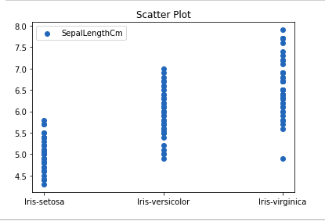

*Scatter plot using matplotlib library*

**Box Plot**

A [boxplot](https://www.geeksforgeeks.org/box-plot-in-python-using-matplotlib/),Correlation also known as a box and whisker plot. It is a very good visual representation when it comes to measuring the data distribution. Clearly plots the median values, outliers and the quartiles. Understanding data distribution is another important factor which leads to better model building. If data has outliers, box plot is a recommended way to identify them and take necessary actions. The box and whiskers chart shows how data is spread out. Five pieces of information are generally included in the chart

* The minimum is shown at the far left of the chart, at the end of the left ‘whisker’
* First quartile, Q1, is the far left of the box (left whisker)
* The median is shown as a line in the center of the box
* Third quartile, Q3, shown at the far right of the box (right whisker)
* The maximum is at the far right of the box

Representation of box plot

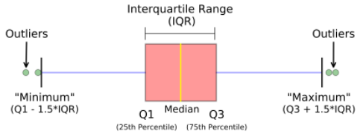

*Inter quartile range*

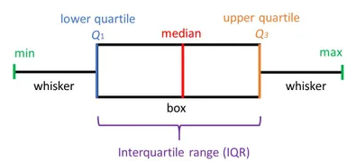

*Illustrating box plot*

**Python Matplotlib Box Plot**

**import** **matplotlib.pyplot** **as** **plt**

**import** **pandas** **as** **pd**

df = pd.read_csv("Iris.csv")

plt.boxplot(df["SepalWidthCm"])

plt.title("Box Plot")

plt.legend(["SepalWidthCm"])

plt.show()

**Output:**

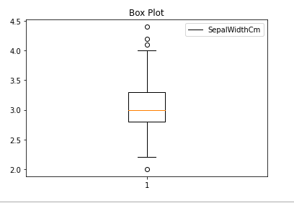

*Boxplot using matplotlib library*

**Correlation Heatmaps**

A 2-D Heatmap is a data visualization tool that helps to represent the magnitude of the phenomenon in form of colors. A correlation heatmap is a heatmap that shows a 2D correlation matrix between two discrete dimensions, using colored cells to represent data from usually a monochromatic scale. The values of the first dimension appear as the rows of the table while the second dimension is a column. The color of the cell is proportional to the number of measurements that match the dimensional value. This makes correlation heatmaps ideal for data analysis since it makes patterns easily readable and highlights the differences and variation in the same data. A correlation heatmap, like a regular heatmap, is assisted by a colorbar making data easily readable and comprehensible.

**Note:**The data here has to be passed with corr() method to generate a correlation heatmap. Also, corr() itself eliminates columns that will be of no use while generating a correlation heatmap and selects those which can be used.

**Python Matplotlib Correlation Heatmap**

**import** **matplotlib.pyplot** **as** **plt**

**import** **pandas** **as** **pd**

df = pd.read_csv("Iris.csv")

plt.imshow(df.corr() , cmap = 'autumn' , interpolation = 'nearest' )

plt.title("Heat Map")

plt.show()

**Output:**

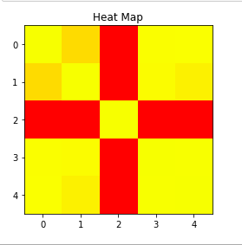

*Heatmap using matplotlib library*

***For more information on data visualization refer to our below tutorials –***

* [*Data Visualization using Matplotlib*](https://www.geeksforgeeks.org/data-visualization-using-matplotlib/)
* [*Data Visualization with Python Seaborn*](https://www.geeksforgeeks.org/data-visualization-with-python-seaborn/)
* [*Data Visualisation in Python using Matplotlib and Seaborn*](https://www.geeksforgeeks.org/data-visualisation-in-python-using-matplotlib-and-seaborn/)
* [*Using Plotly for Interactive Data Visualization in Python*](https://www.geeksforgeeks.org/using-plotly-for-interactive-data-visualization-in-python/)
* [*Interactive Data Visualization with Bokeh*](https://www.geeksforgeeks.org/python-bokeh-tutorial-interactive-data-visualization-with-bokeh/)

**Exploratory Data Analysis**

[Exploratory Data Analysis (EDA)](https://www.geeksforgeeks.org/what-is-exploratory-data-analysis/) is a technique to analyze data using some visual Techniques. With this technique, we can get detailed information about the statistical summary of the data. We will also be able to deal with the duplicates values, outliers, and also see some trends or patterns present in the dataset.

**Note:** We will be using Iris Dataset.

**Getting Information about the Dataset**

We will use the shape parameter to get the shape of the dataset.

**Shape of Dataframe**

df.shape

**Output:**

(150, 6)

We can see that the dataframe contains 6 columns and 150 rows.

Now, let’s also the columns and their data types. For this, we will use the [info()](https://www.geeksforgeeks.org/python-pandas-dataframe-info/) method.

**Information about Dataset**

df.info()

**Output:**

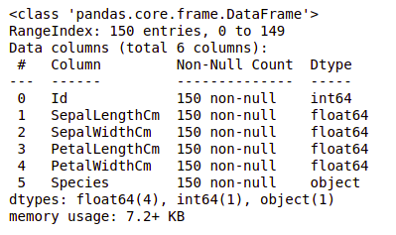

*information about the dataset*

We can see that only one column has categorical data and all the other columns are of the numeric type with non-Null entries.

Let’s get a quick statistical summary of the dataset using the [**describe()**](https://www.geeksforgeeks.org/python-pandas-dataframe-describe-method/) method. The describe() function applies basic statistical computations on the dataset like extreme values, count of data points standard deviation, etc. Any missing value or NaN value is automatically skipped. describe() function gives a good picture of the distribution of data.

**Description of dataset**

df.describe()

**Output:**

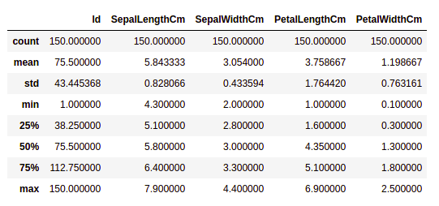

*Description about the dataset*

We can see the count of each column along with their mean value, standard deviation, minimum and maximum values.

**Checking Missing Values**

We will check if our data contains any missing values or not. Missing values can occur when no information is provided for one or more items or for a whole unit. We will use the [isnull()](https://www.geeksforgeeks.org/python-pandas-isnull-and-notnull/) method.

**python code for missing value**

df.isnull().sum()

**Output:**

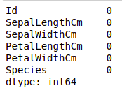

*Missing values in the dataset*

We can see that no column has any missing value.

**Checking Duplicates**

Let’s see if our dataset contains any duplicates or not. Pandas [drop_duplicates()](https://www.geeksforgeeks.org/python-pandas-dataframe-drop_duplicates/) method helps in removing duplicates from the data frame.

**Pandas function for missing values**

data = df.drop_duplicates(subset ="Species",)  
data

**Output:**

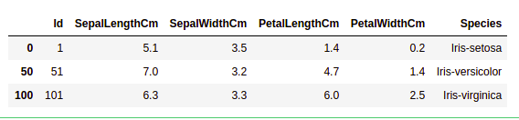

*Dropping duplicate value in the dataset*

We can see that there are only three unique species. Let’s see if the dataset is balanced or not i.e. all the species contain equal amounts of rows or not. We will use the [Series.value_counts()](https://www.geeksforgeeks.org/python-pandas-series-value_counts/) function. This function returns a Series containing counts of unique values.

**Python code for value counts in the column**

df.value_counts("Species")

**Output:**

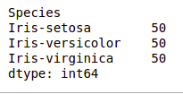

*value count in the dataset*

We can see that all the species contain an equal amount of rows, so we should not delete any entries.

**Relation between variables**

We will see the relationship between the sepal length and sepal width and also between petal length and petal width.

**Comparing Sepal Length and Sepal Width**

**import** **seaborn** **as** **sns**

**import** **matplotlib.pyplot** **as** **plt**

sns.scatterplot(x='SepalLengthCm', y='SepalWidthCm',

hue='Species', data=df, )

plt.legend(bbox_to_anchor=(1, 1), loc=2)

plt.show()

**Output:**

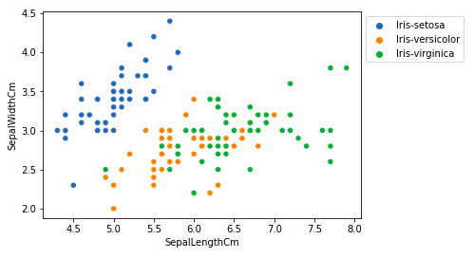

*Scatter plot using matplotlib library*

From the above plot, we can infer that –

* Species Setosa has smaller sepal lengths but larger sepal widths.
* Versicolor Species lies in the middle of the other two species in terms of sepal length and width
* Species Virginica has larger sepal lengths but smaller sepal widths.

**Comparing Petal Length and Petal Width**

**import** **seaborn** **as** **sns**

**import** **matplotlib.pyplot** **as** **plt**

sns.scatterplot(x='PetalLengthCm', y='PetalWidthCm',

hue='Species', data=df, )

plt.legend(bbox_to_anchor=(1, 1), loc=2)

plt.show()

**Output:**

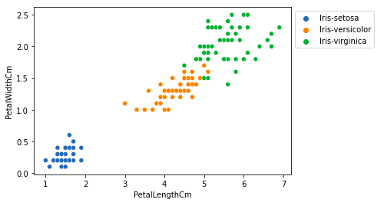

*sactter plot petal length*

From the above plot, we can infer that –

* The species Setosa has smaller petal lengths and widths.
* Versicolor Species lies in the middle of the other two species in terms of petal length and width
* Species Virginica has the largest petal lengths and widths.

Let’s plot all the column’s relationships using a pairplot. It can be used for multivariate analysis.

**Python code for pairplot**

**import** **seaborn** **as** **sns**

**import** **matplotlib.pyplot** **as** **plt**

sns.pairplot(df.drop(['Id'], axis = 1),

hue='Species', height=2)

**Output:**

*Pairplot for the dataset*

We can see many types of relationships from this plot such as the species Seotsa has the smallest of petals widths and lengths. It also has the smallest sepal length but larger sepal widths. Such information can be gathered about any other species.

**Handling Correlation**

Pandas [dataframe.corr()](https://www.geeksforgeeks.org/python-pandas-dataframe-corr/) is used to find the pairwise correlation of all columns in the dataframe. Any NA values are automatically excluded. Any non-numeric data type columns in the dataframe are ignored.

**Example:**

data.corr(method='pearson')

**Output:**

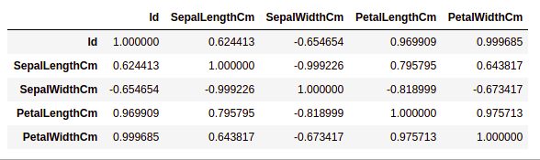

*correlation between columns in the dataset*

**Heatmaps**

The heatmap is a data visualization technique that is used to analyze the dataset as colors in two dimensions. Basically, it shows a correlation between all numerical variables in the dataset. In simpler terms, we can plot the above-found correlation using the heatmaps.

**python code for heatmap**

**import** **seaborn** **as** **sns**

**import** **matplotlib.pyplot** **as** **plt**

sns.heatmap(df.corr(method='pearson').drop(

['Id'], axis=1).drop(['Id'], axis=0),

annot = **True**);

plt.show()

**Output:**

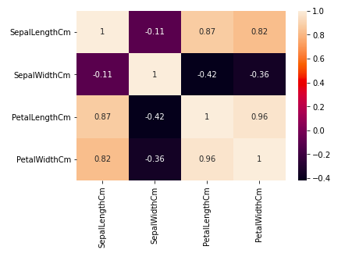

*Heatmap for correlation in the dataset*

From the above graph, we can see that –

* Petal width and petal length have high correlations.
* Petal length and sepal width have good correlations.
* Petal Width and Sepal length have good correlations.

**Handling Outliers**

An Outlier is a data item/object that deviates significantly from the rest of the (so-called normal)objects. They can be caused by measurement or execution errors. The analysis for outlier detection is referred to as outlier mining. There are many ways to detect outliers, and the removal process is the data frame same as removing a data item from the panda’s dataframe.

Let’s consider the iris dataset and let’s plot the boxplot for the SepalWidthCm column.

**python code for Boxplot**

**import** **seaborn** **as** **sns**

**import** **matplotlib.pyplot** **as** **plt**

df = pd.read_csv('Iris.csv')

sns.boxplot(x='SepalWidthCm', data=df)

**Output:**

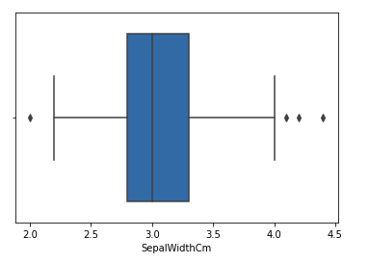

*Boxplot for sepalwidth column*

In the above graph, the values above 4 and below 2 are acting as outliers.

**Removing Outliers**

For removing the outlier, one must follow the same process of removing an entry from the dataset using its exact position in the dataset because in all the above methods of detecting the outliers end result is the list of all those data items that satisfy the outlier definition according to the method used.

We will detect the outliers using [IQR](https://www.geeksforgeeks.org/interquartile-range-iqr/) and then we will remove them. We will also draw the boxplot to see if the outliers are removed or not.

**import** **sklearn**

**from** **sklearn.datasets** **import** load_boston

**import** **pandas** **as** **pd**

**import** **seaborn** **as** **sns**

df = pd.read_csv('Iris.csv')

Q1 = np.percentile(df['SepalWidthCm'], 25,

interpolation = 'midpoint')

Q3 = np.percentile(df['SepalWidthCm'], 75,

interpolation = 'midpoint')

IQR = Q3 - Q1

print("Old Shape: ", df.shape)

upper = np.where(df['SepalWidthCm'] >= (Q3+1.5*IQR))

lower = np.where(df['SepalWidthCm'] <= (Q1-1.5*IQR))

df.drop(upper[0], inplace = **True**)

df.drop(lower[0], inplace = **True**)

print("New Shape: ", df.shape)

sns.boxplot(x='SepalWidthCm', data=df)

**Output:**

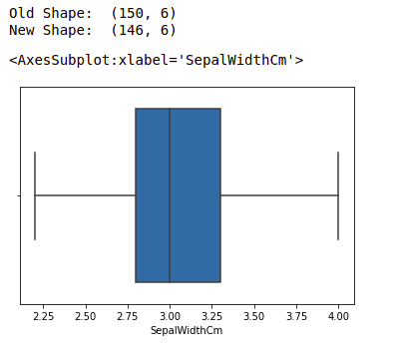

*boxplot using seaborn library*

***For more information about EDA, refer to our below tutorials –***

* [*What is Exploratory Data Analysis ?*](https://www.geeksforgeeks.org/what-is-exploratory-data-analysis/)
* [*Exploratory Data Analysis in Python | Set 1*](https://www.geeksforgeeks.org/exploratory-data-analysis-in-python-set-1/)
* [*Exploratory Data Analysis in Python | Set 2*](https://www.geeksforgeeks.org/exploratory-data-analysis-in-python-set-2/)
* [*Exploratory Data Analysis on Iris Dataset*](https://www.geeksforgeeks.org/exploratory-data-analysis-on-iris-dataset/)